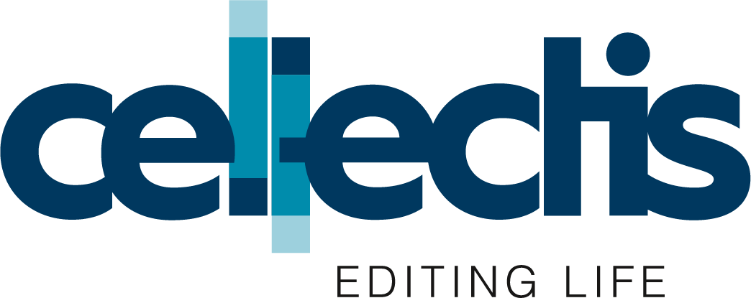

Monthly information on share capital and company voting rights
(Article 223-16 of General Regulation of the French financial markets authority)

Listing market: Euronext Growth
ISIN code: FR0010425595
Date | Total number of shares  in the capital | Total number of voting rights
06/30/2022 | 45,461,310 | 51,531,339
About Cellectis
Cellectis is a clinical-stage biotechnology company using its pioneering gene-editing platform to develop life-saving cell and gene therapies. Cellectis utilizes an allogeneic approach for CAR-T immunotherapies in oncology, pioneering the concept of off-the-shelf and ready-to-use gene-edited CAR T-cells to treat cancer patients, and a platform to make therapeutic gene editing in hemopoietic stem cells for various diseases. As a clinical-stage biopharmaceutical company with over 22 years of expertise in gene editing, Cellectis is developing life-changing product candidates utilizing TALEN®, its gene editing technology, and PulseAgile, its pioneering electroporation system to harness the power of the immune system in order to treat diseases with unmet medical needs. As part of its commitment to a cure, Cellectis remains dedicated to its goal of providing lifesaving UCART product candidates for multiple cancers including acute myeloid leukemia (AML), B-cell acute lymphoblastic leukemia (B-ALL) and multiple myeloma (MM). .HEAL is a new platform focusing on hemopoietic stem cells to treat blood disorders, immunodeficiencies and lysosomal storage diseases.
Cellectis’ headquarters are in Paris, France, with locations in New York, New York and Raleigh, North Carolina.
Cellectis is listed on the Nasdaq Global Market (ticker: CLLS) and on Euronext Growth (ticker: ALCLS).

For more information, visit www.cellectis.com
Follow Cellectis on social media: @cellectis, LinkedIn and YouTube.
For further information, please contact:
Media contacts:
Pascalyne Wilson, Director, Communications, +33776991433, media@cellectis.com
Margaret Gandolfo, Senior Manager, Communications, +1 (646) 628 0300
Investor Relation contact:
Arthur Stril, Chief Business Officer, +1 (347) 809 5980, investors@cellectis.com
Ashley R. Robinson, LifeSci Advisors, +1 (617) 430 7577

###

